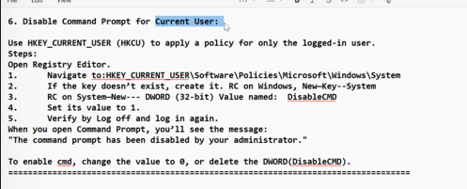
imp block notepad and command prompt
imp and any one which we did it from yesterday
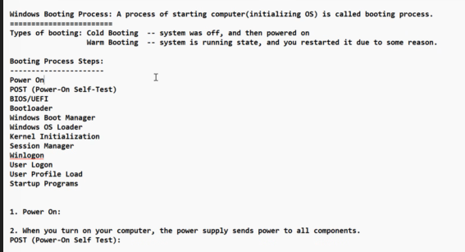
Intel AMI are BIOS company
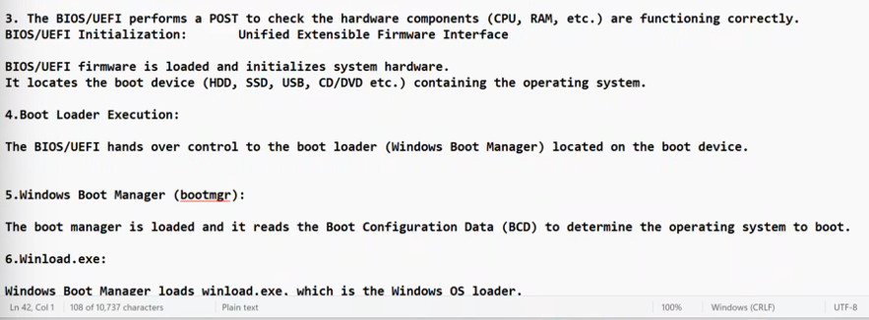
Steps of booting
VIVA What is the boot loader of your windows --> Answer is Windows Boot Manager or BootMgr
BCD is Boot Configuration Data …Boot Mgr reads this
it contains how many OS do you have like win 8 win 10 etc …default one
waiting time kitna hai etc …
BCD File ka naam hai
Winload is loaded by Boot MGR ….the file name is winload.exe the name Is windows loader
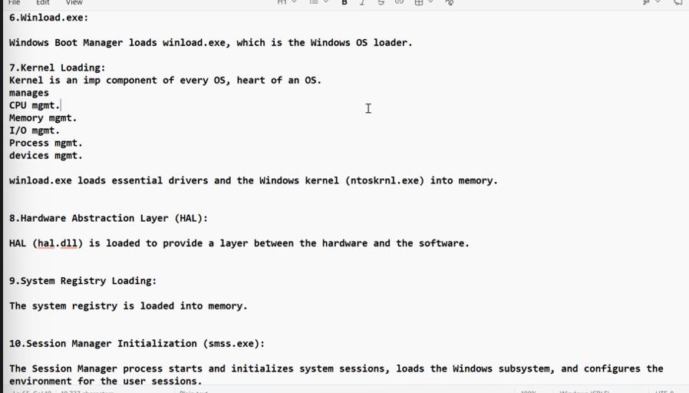
Kernel is heart and brain of OS
Windows kernel ka naam ntoskenl.exe hai and winload.exe load karne wale ka naam hai ..
kernal loads 2 things the sound audio etc part and kernel of windows ka …
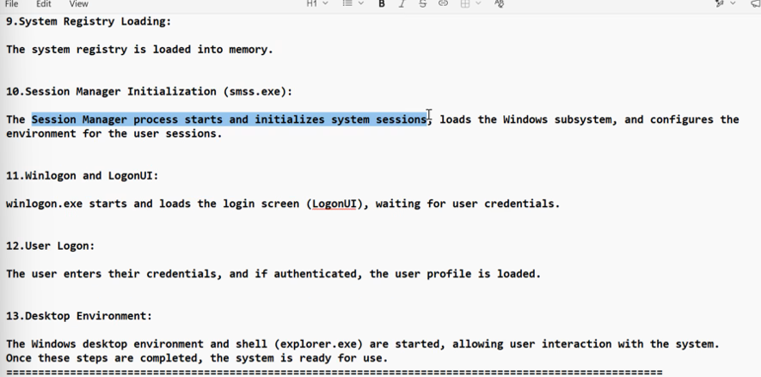
Buisness Unit CIS
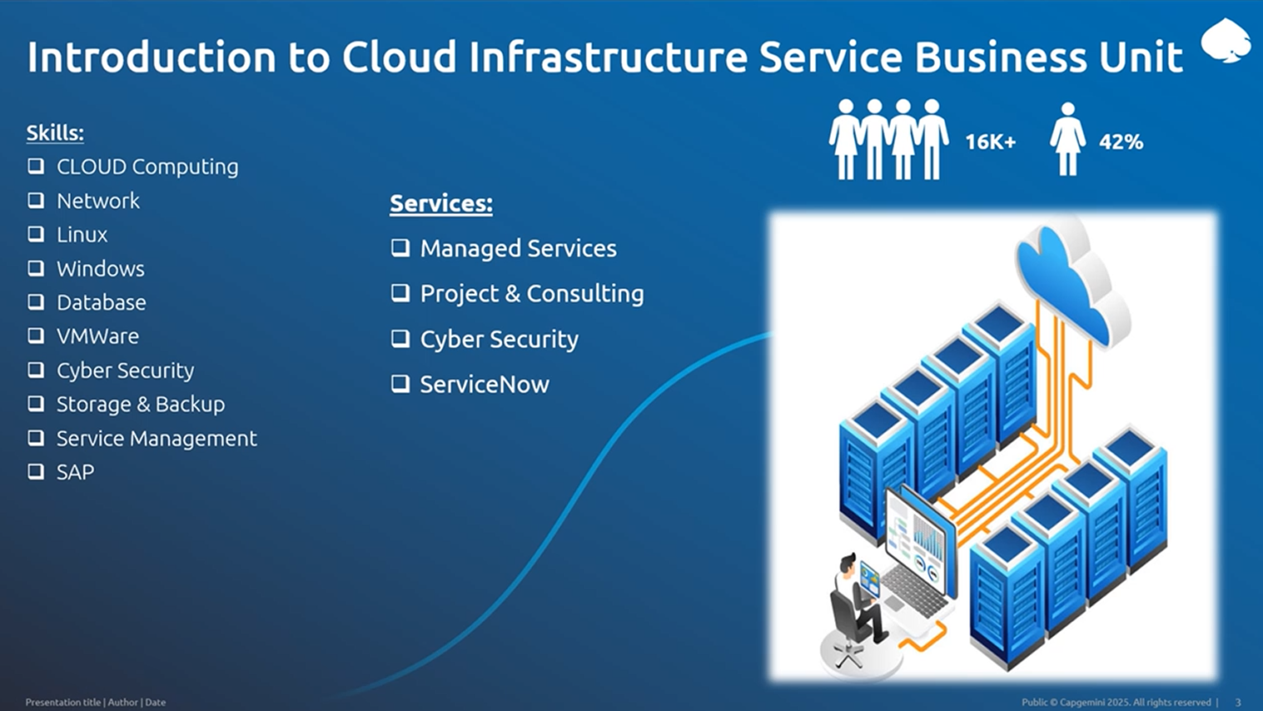
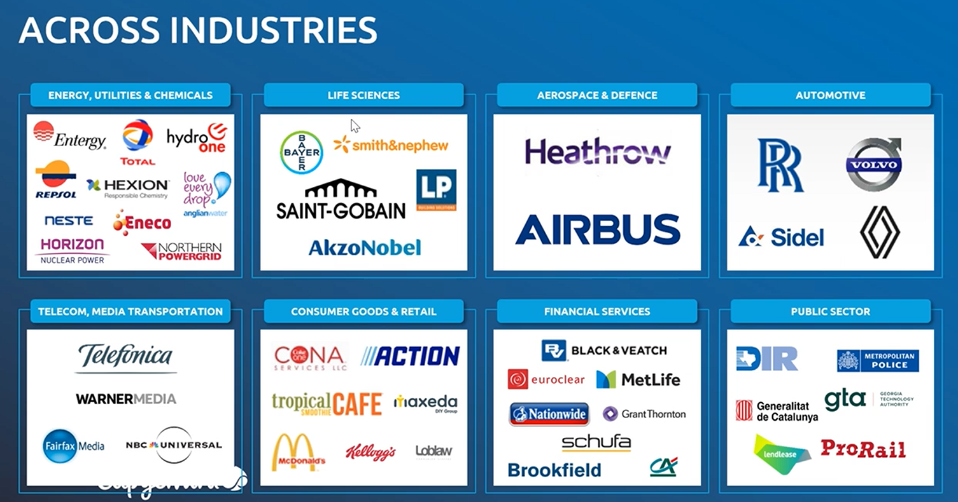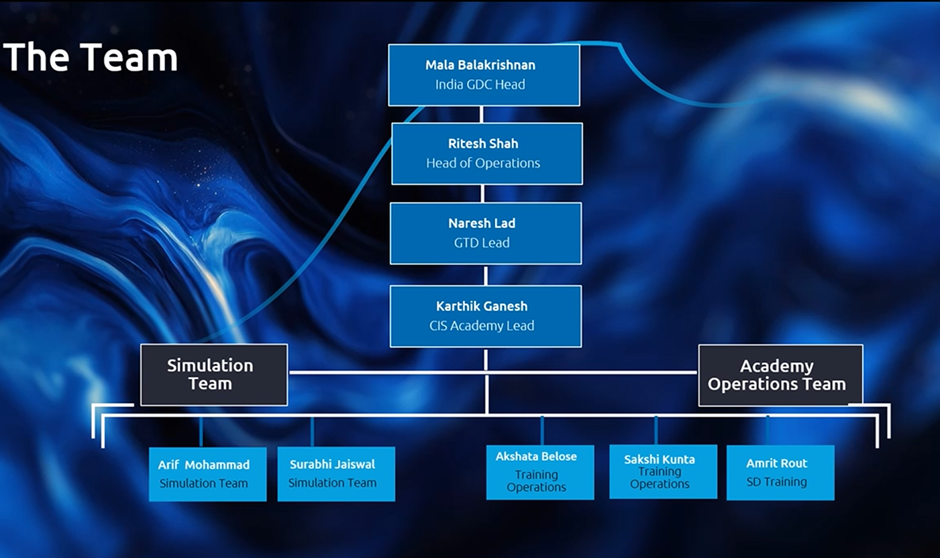
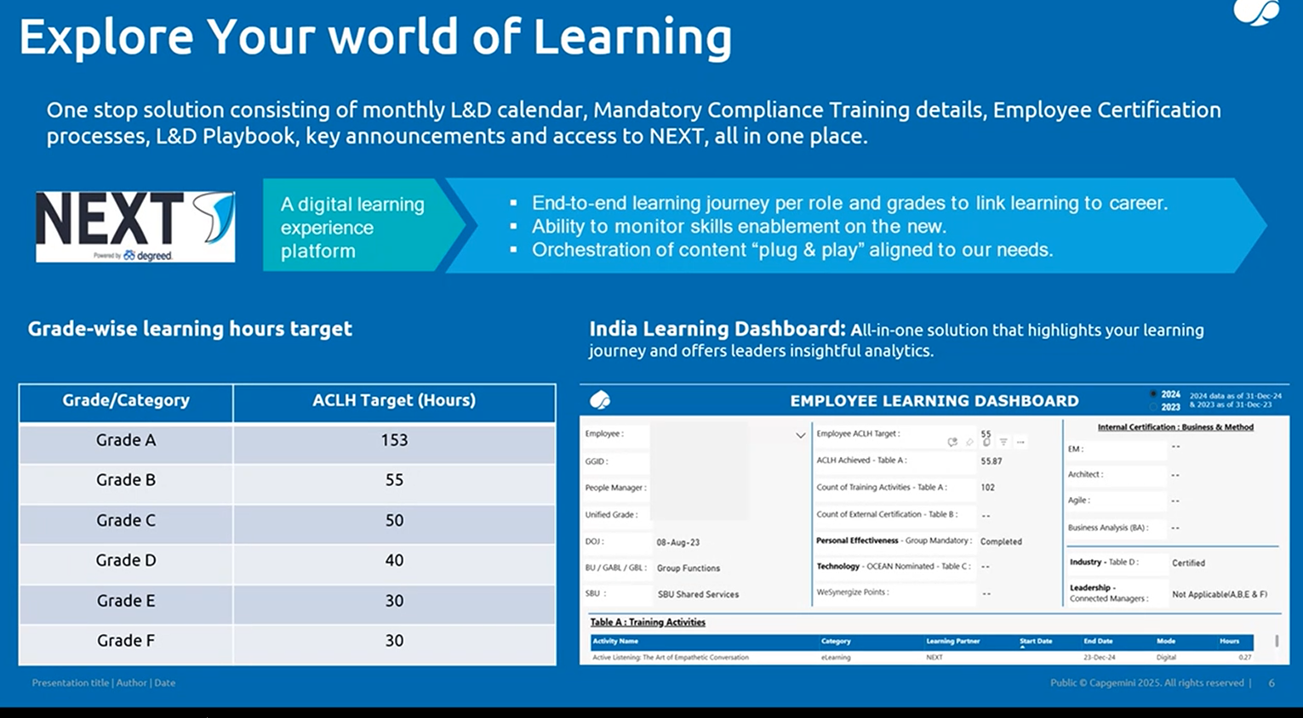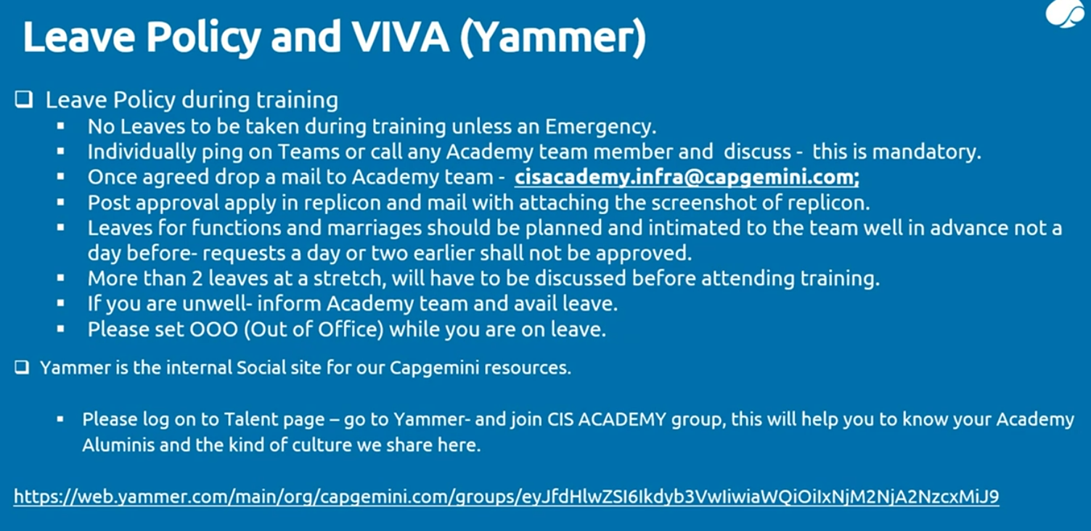
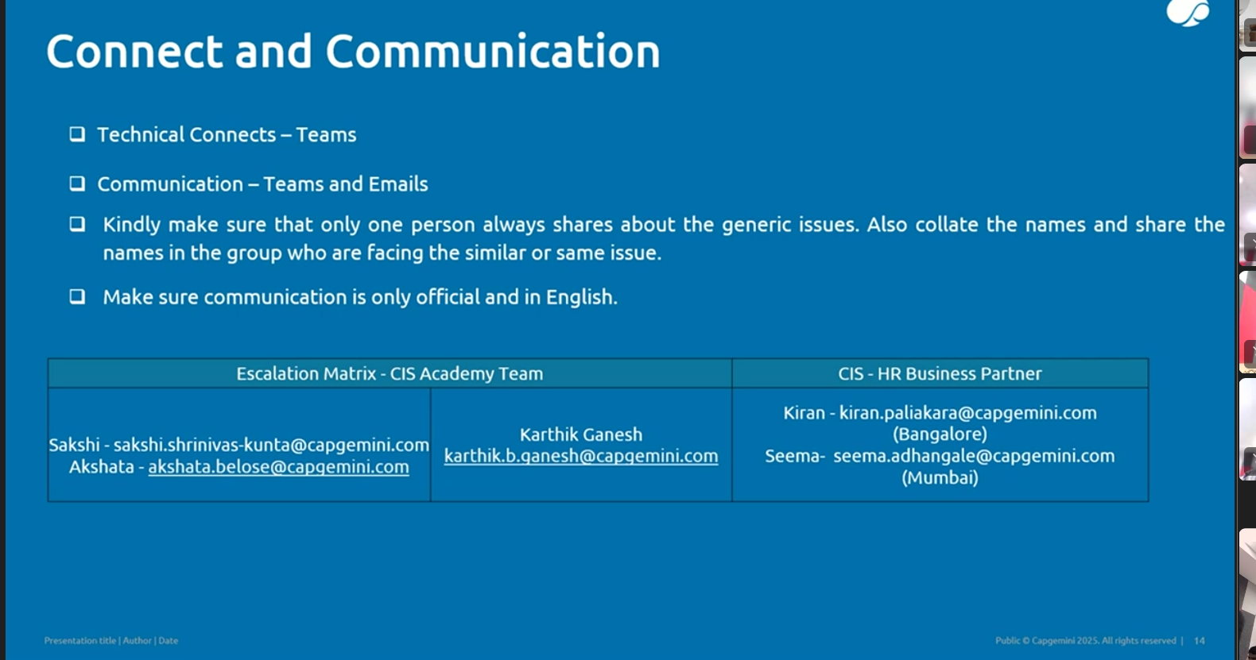
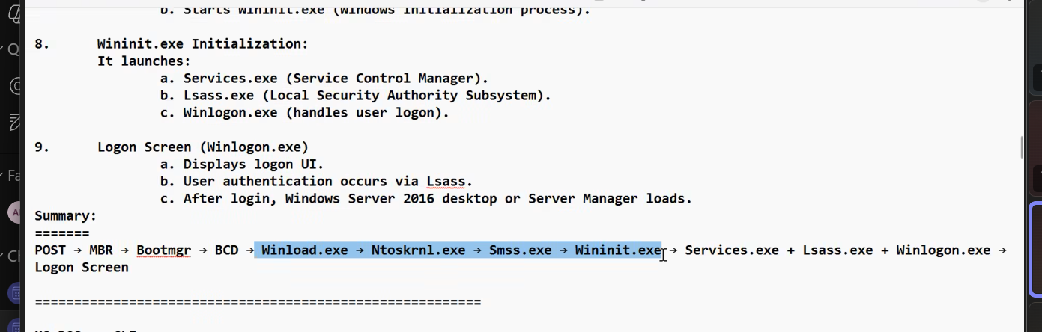
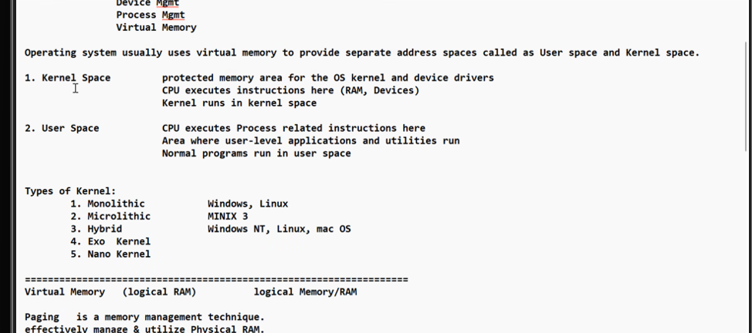
Blue Screen Of Death BSOD
DISK MANAGEMENT
DEVICE MANAGEMENT
EVENT VIEWER MANAGEMENT
IMP topic for practical
Virtual Memory concept of RAM {Physical+logical[virtual ] memery }
imp
Swap/in swap out is a portion of hard drive … VM
so more memory ..
VM is logical RAM and VM is less costly budget friendly ..
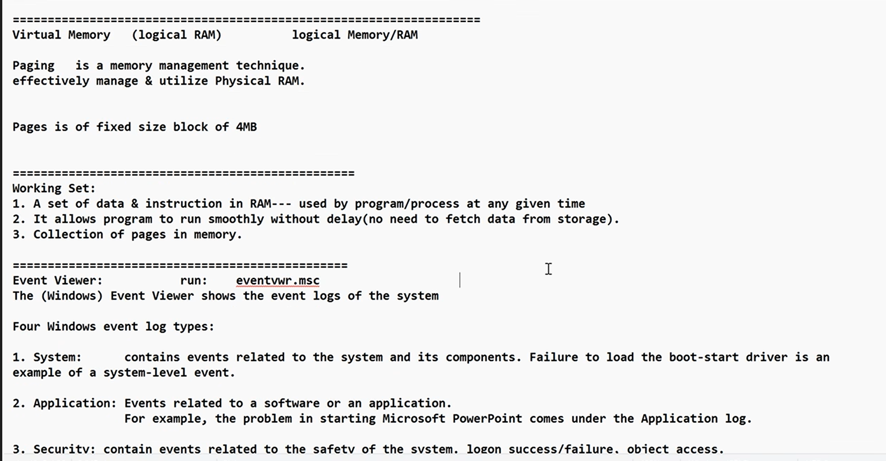
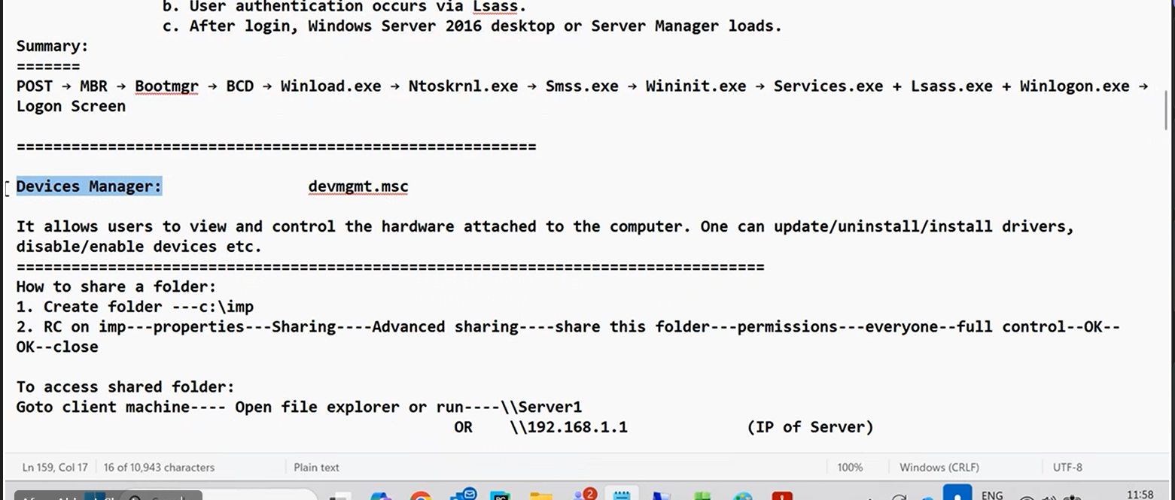 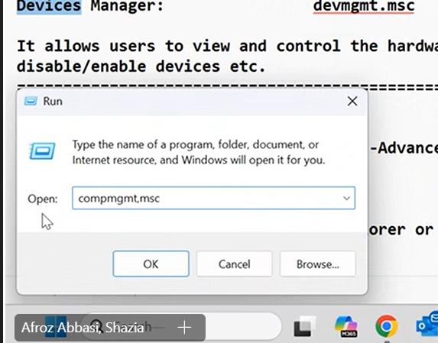
Event Viewer 10 mks (100%)
Disk Managemnt 20 makrs
3 makrs device manager…
shows evet that happened in the past event viewer …bc
Tools-event viewer or search of event viewer
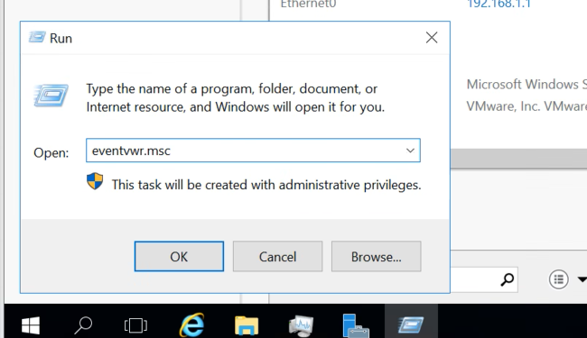
available in ALL OS …event viewer
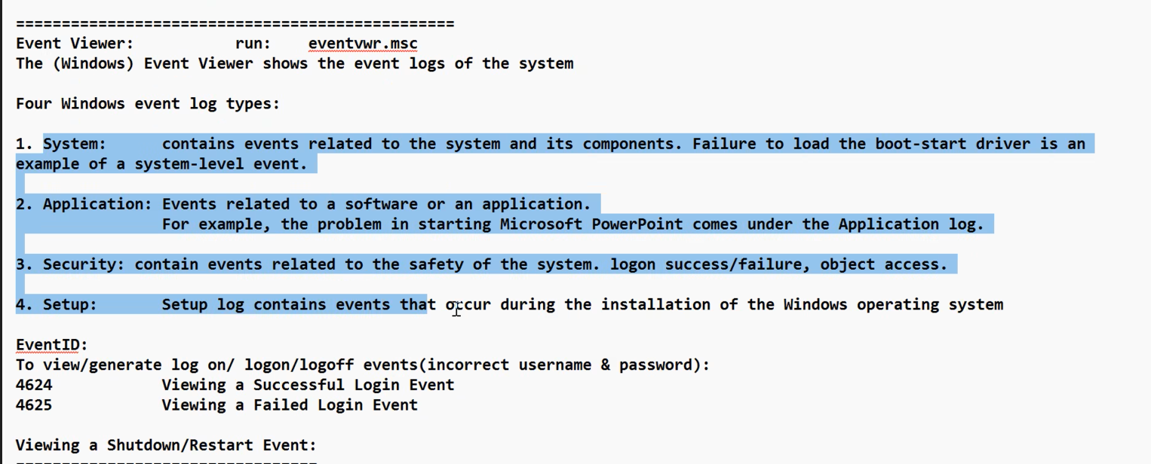
log practical
q1
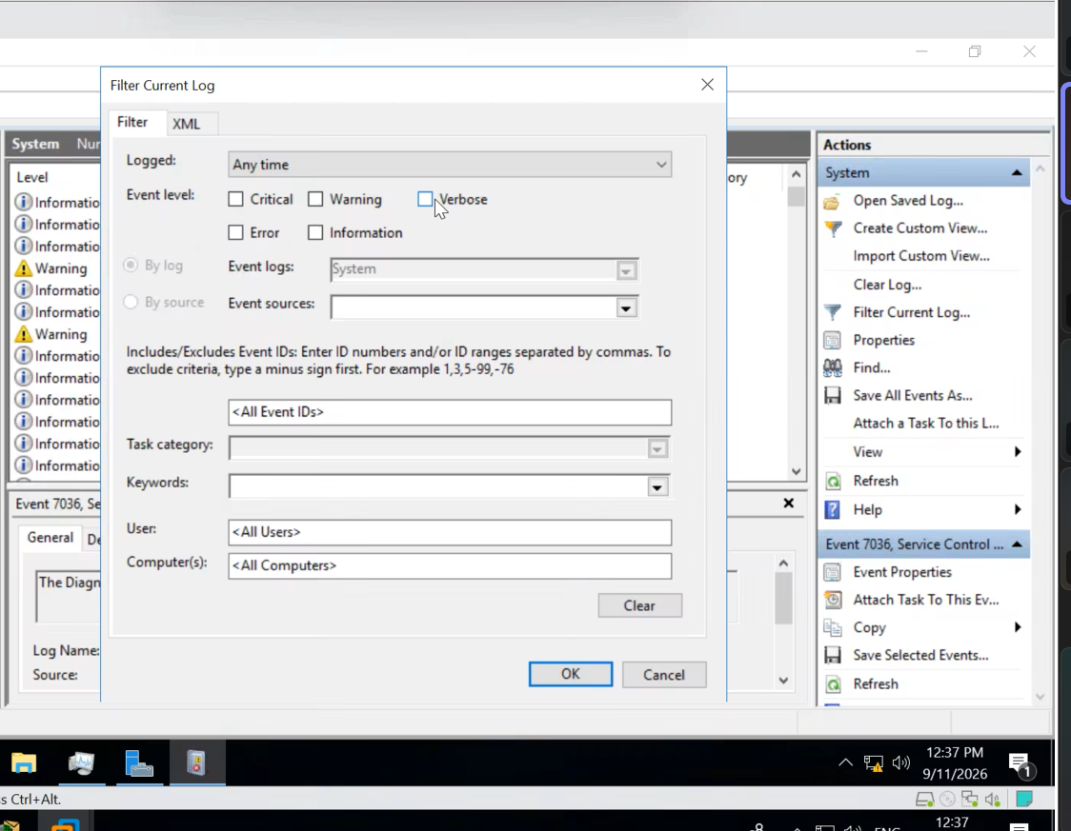
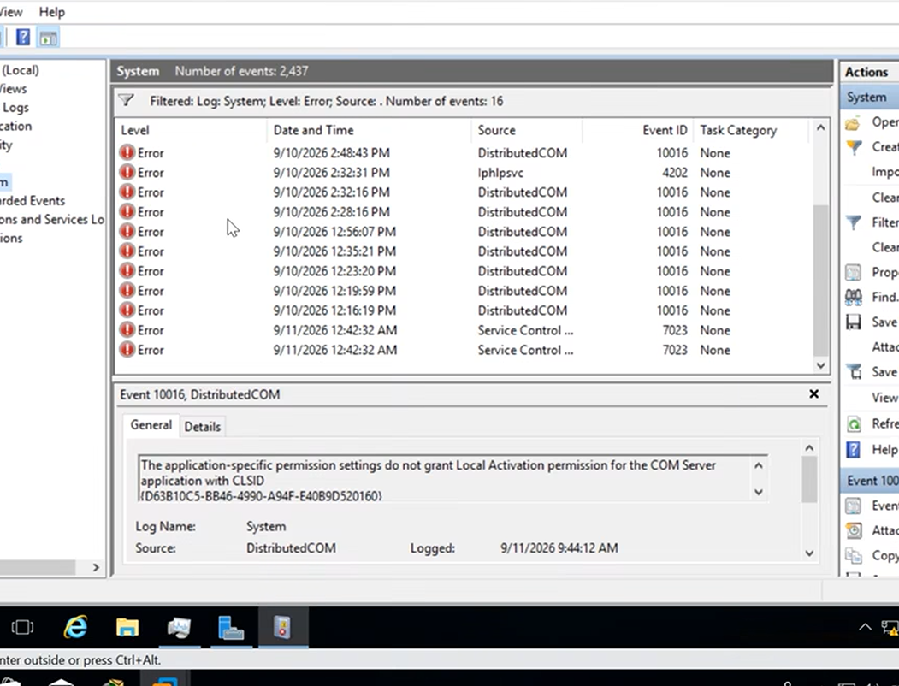
clear filter vs clear log …imp
Aim
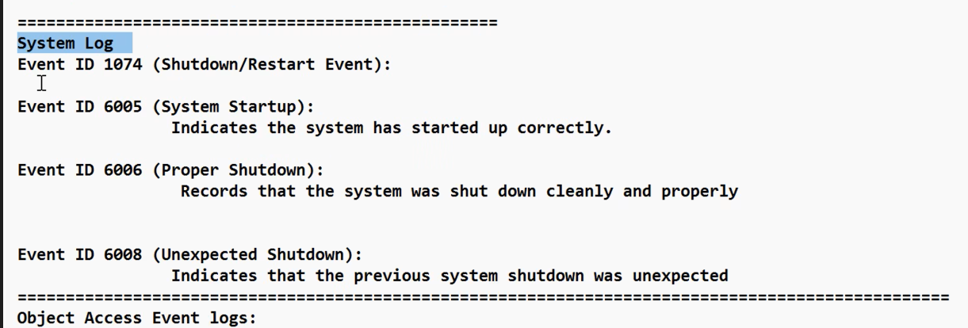
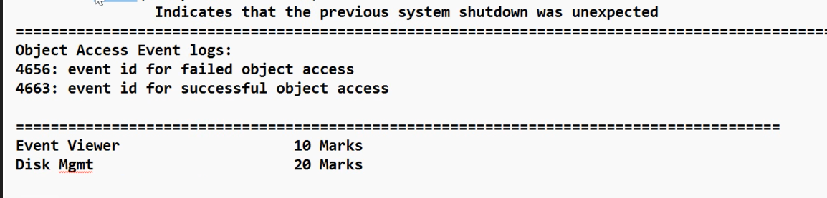
6006,6008
security log
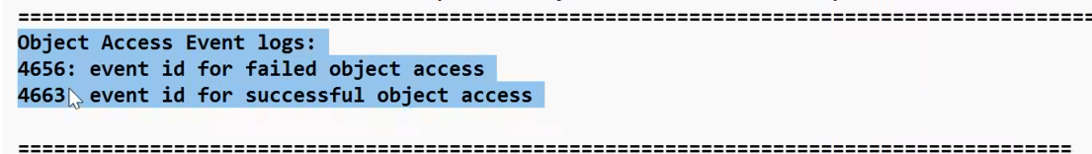
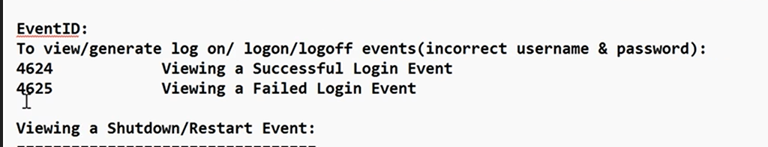
Custom View
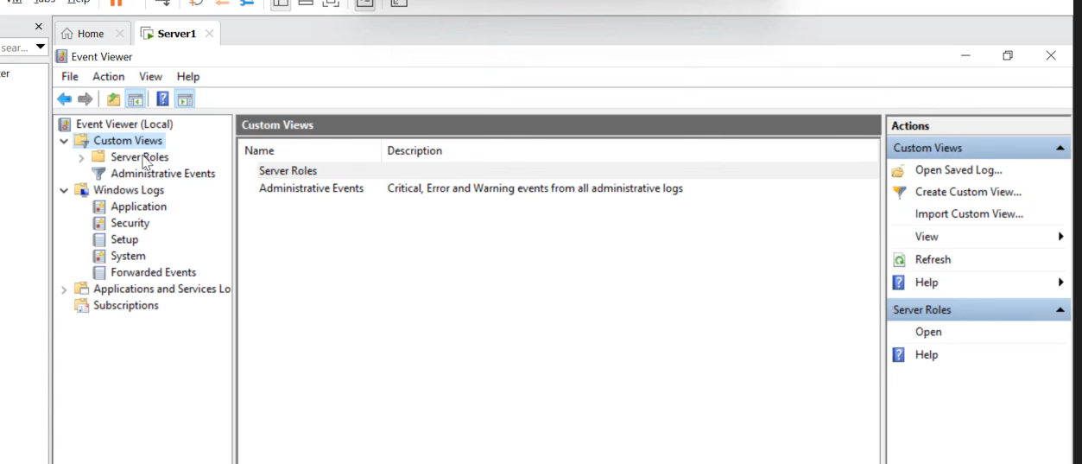
Create custom view
last 24 hrs
critical and warning logs
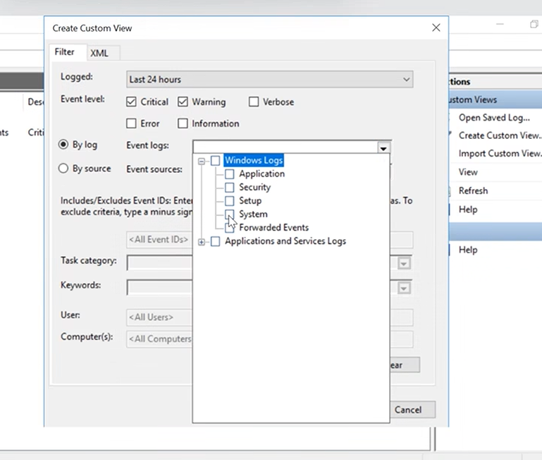
optional
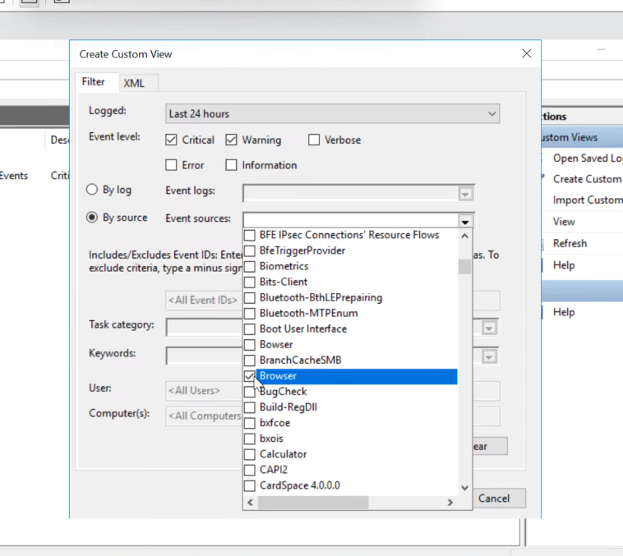
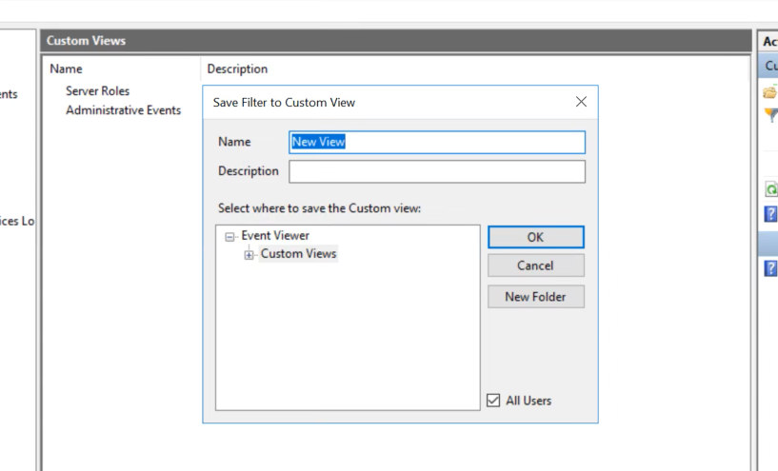
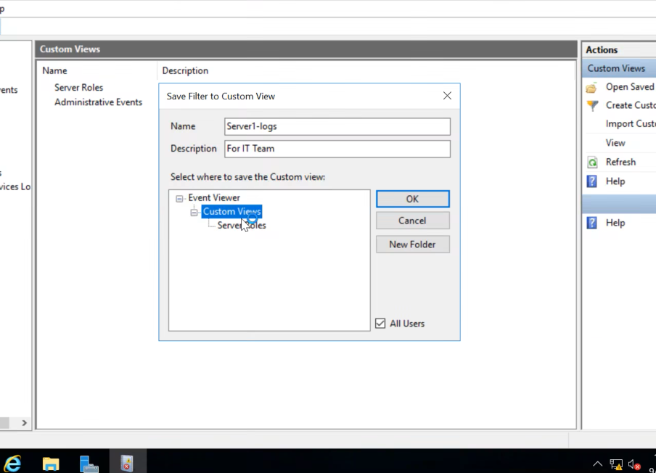
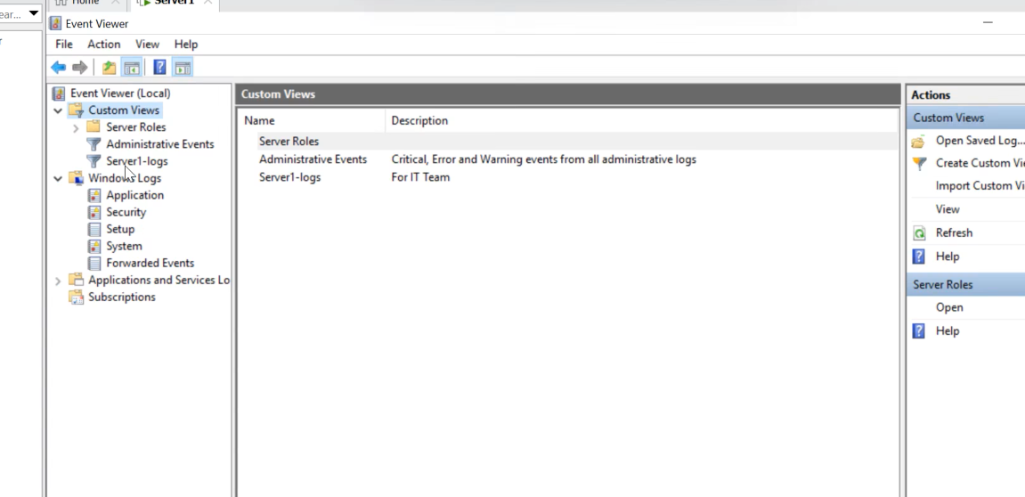
how to clear log :--- I mean save a log you clear and save…imp..bc

Last Topic Disk Management highest weightage 20 marks
Partioitnos hard drive hard disk main secondary storage deives
hard drisk ---- are of 2 types basic and dynamic based on partitions
Diskmgmt.msc
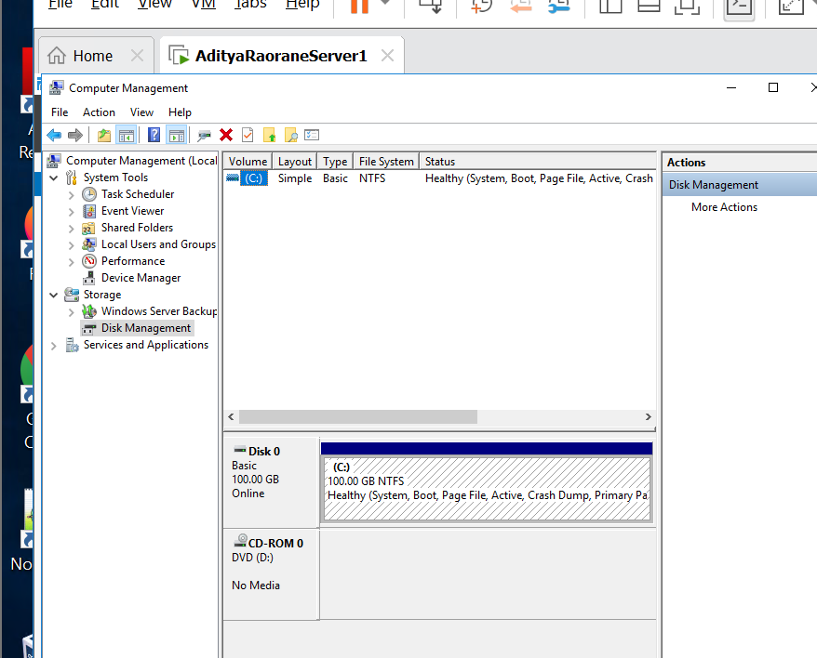
toolscomputer management …disk management
CD ROM

By defulat we don’t have dynamic disk
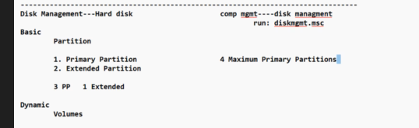
bkl important hai
Dhyan rakh viva and prac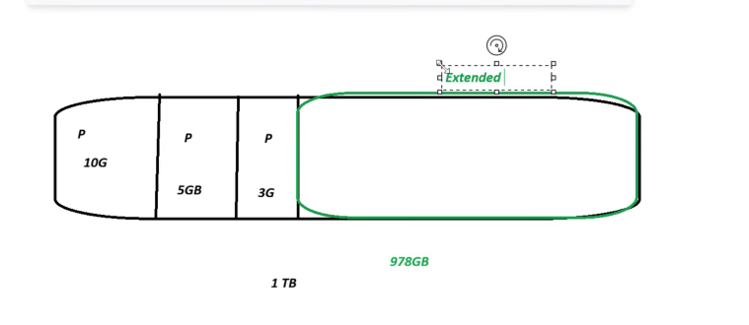
Logical drives are put in the extended drives …..imp
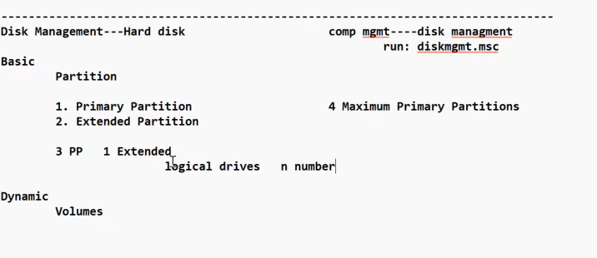
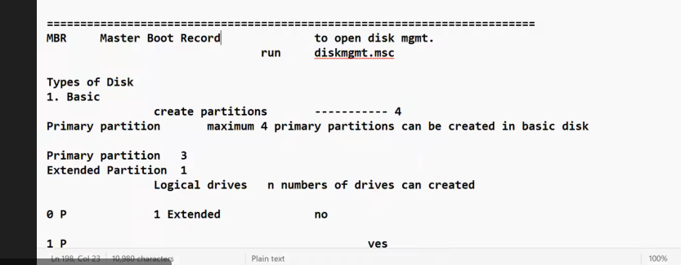
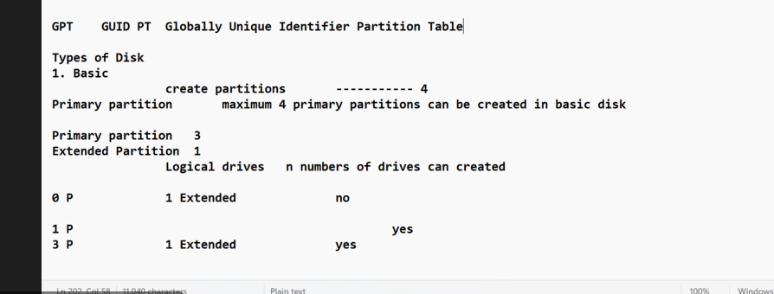
MBR AND GPT are called as hard disk portioning style …imp full form
mbr is old
gpt is new
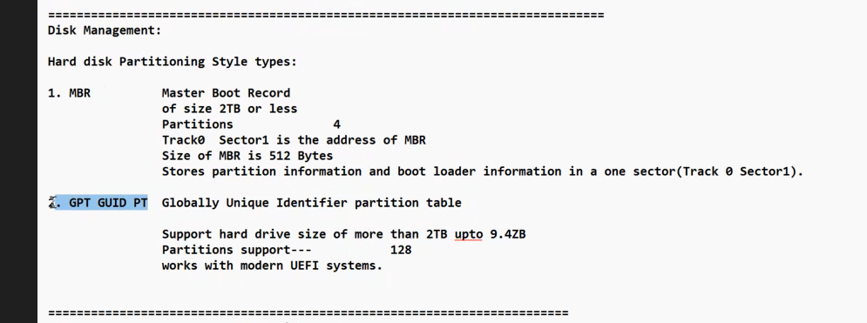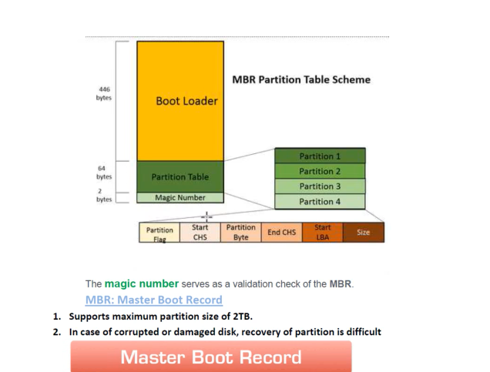
Boot loader mein addres of os hai like kitne os hai ..and kaha par hai etc
whole mbr is of 512 Bytes
magic number is for error checking
imp hai mbr bsdk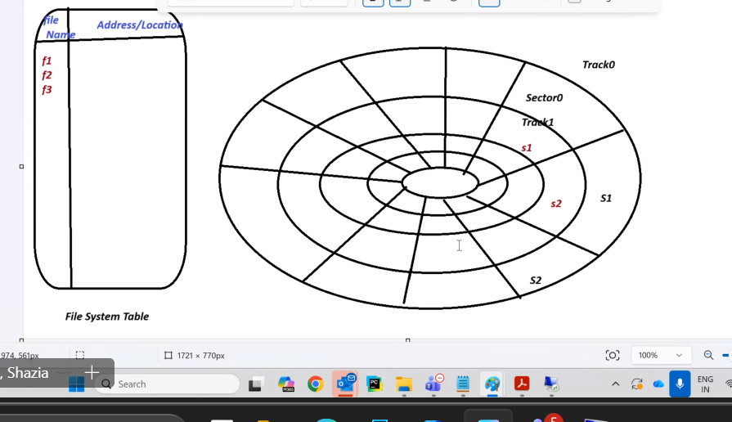
This is called disk anatomy ..
All data is stored in sectors bkl
Each sector can store 512 Bytes…so rest of area is wasted
MBR Track 0 sector 1 of hard disk …location of mbr
GPT -
CAN CREATE 128 primary partition …mkc
GPT vs MBR

File System
Index page of your file and folder ..
Easy to locate your files bc
like file name and its address location
OS refers file system table bc
Helps to save and retreieve your file bc
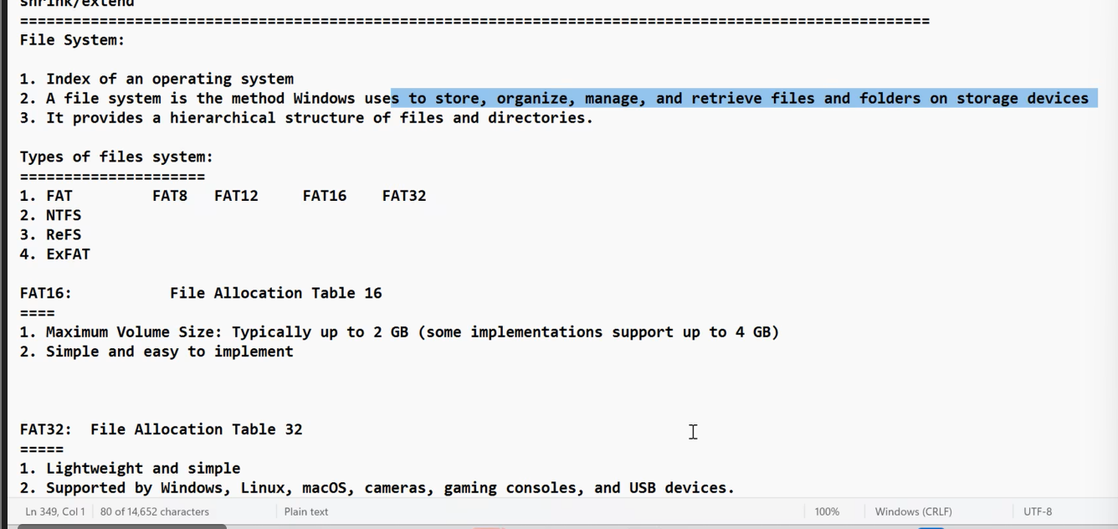
4 main types
!. file allocation table
latest is fat 32 practical
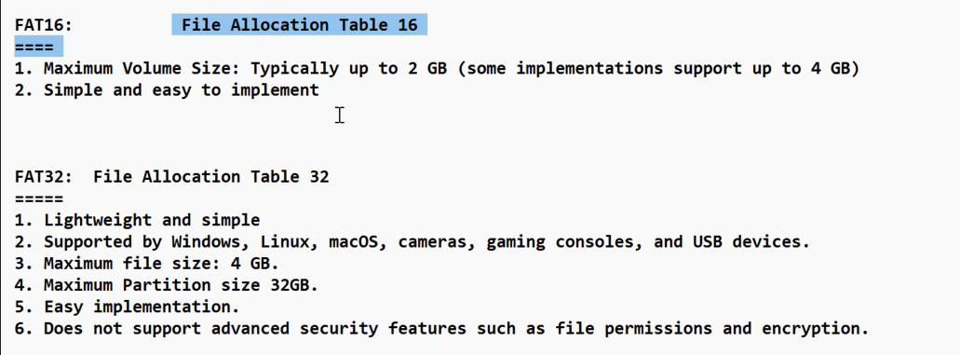
very very very imp
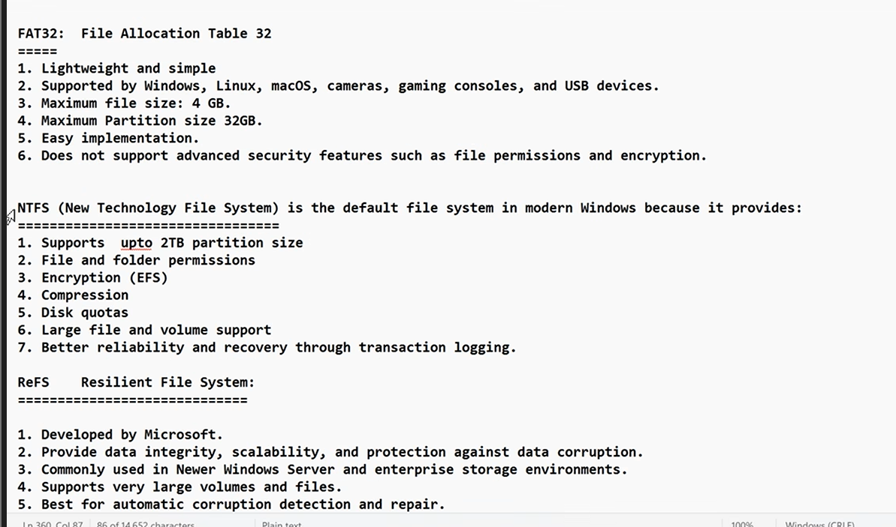
Bkl very very imp
FAT 32
Max file size is 4GB for FAT32 ……..L1 like this …
and max partition size of 32GB

NTFS best hai ….
Supports partition upto 2TB….bc
Supports permission…
Encrypt kar sakte hai via security …only in ntfs
encyyption and data compression
and disk qutota bc reservation
ReFS AFTER win 8 onwards
Only adv is that it supprts larger partition size of 4.7 ZB
and down time or recovery time is very low
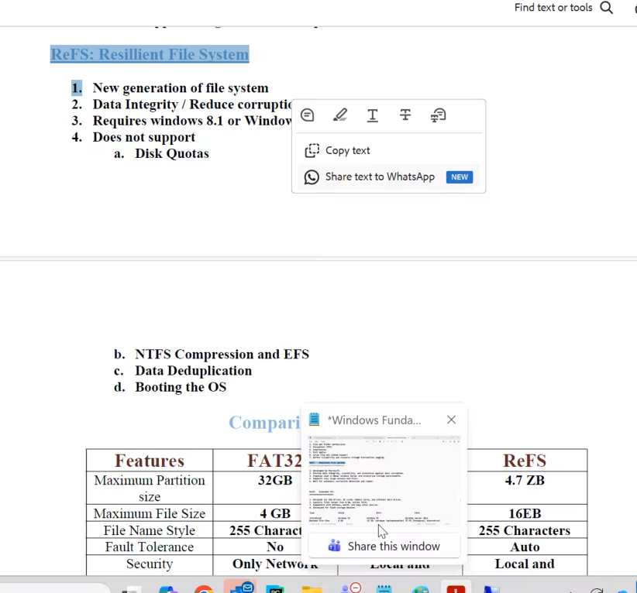
after fat 32
ExFAT
mobile pen drive memory card
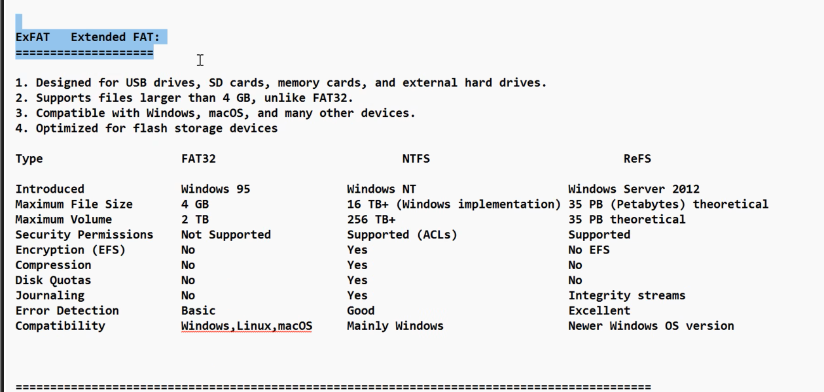
=========================
Practical
aim to create 1 more partion of size 10 GB
ans
extend and shrink …..
on;y in ntfs
1st shrink volme …rightclick of 1dgree
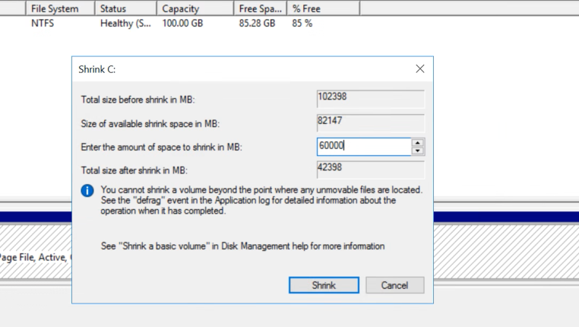
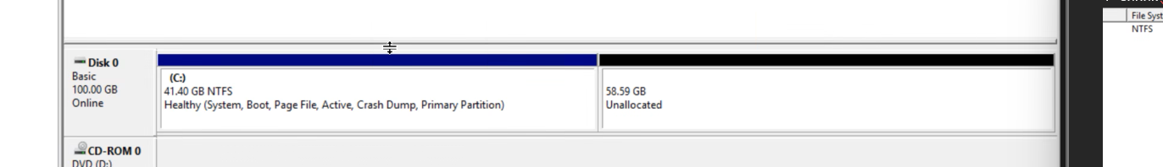
aim to create 3 partitions
one fat32 of size 3GB and drive letter f:
second of ntfs of size 35 gb and drive letter n:
third is of ntfs of size 5GB and letter s:

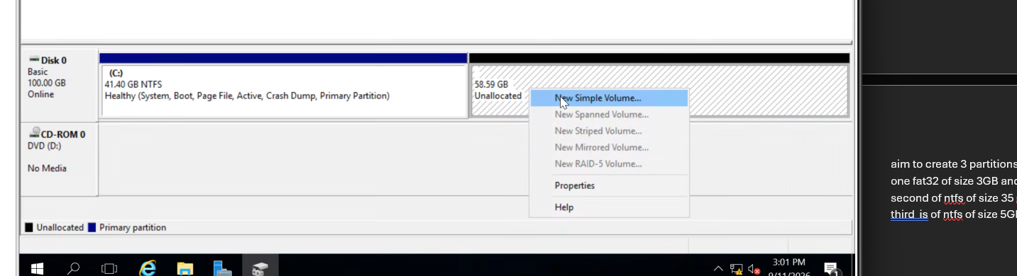
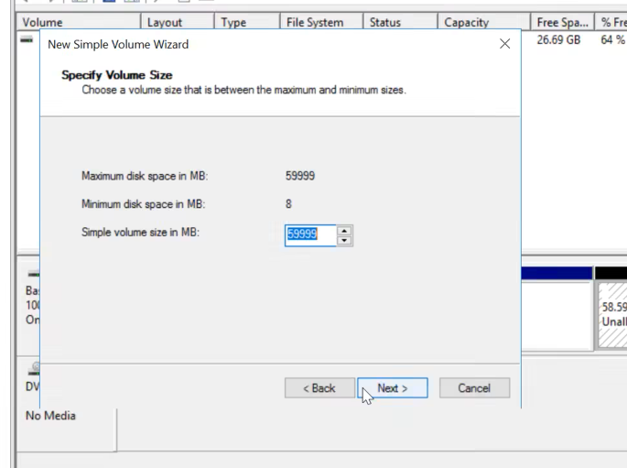
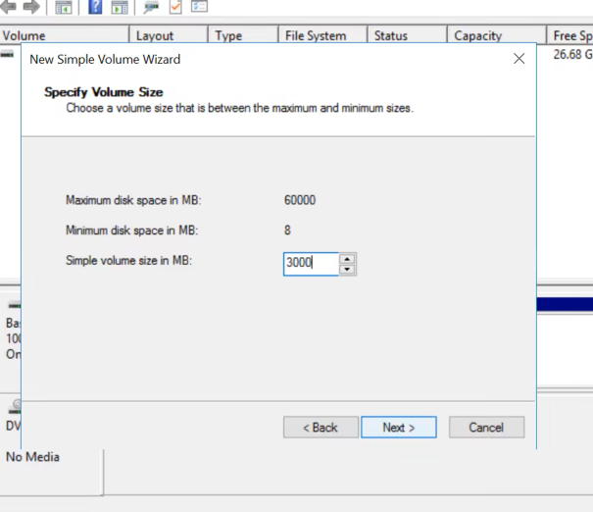
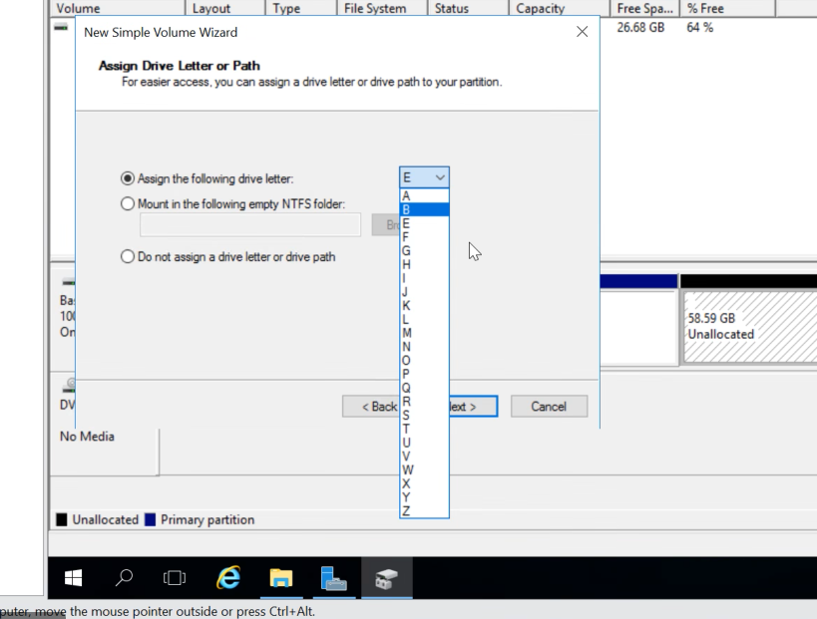
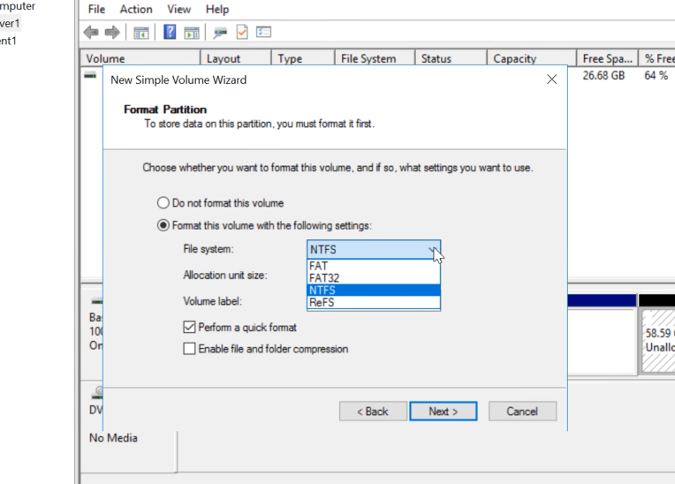
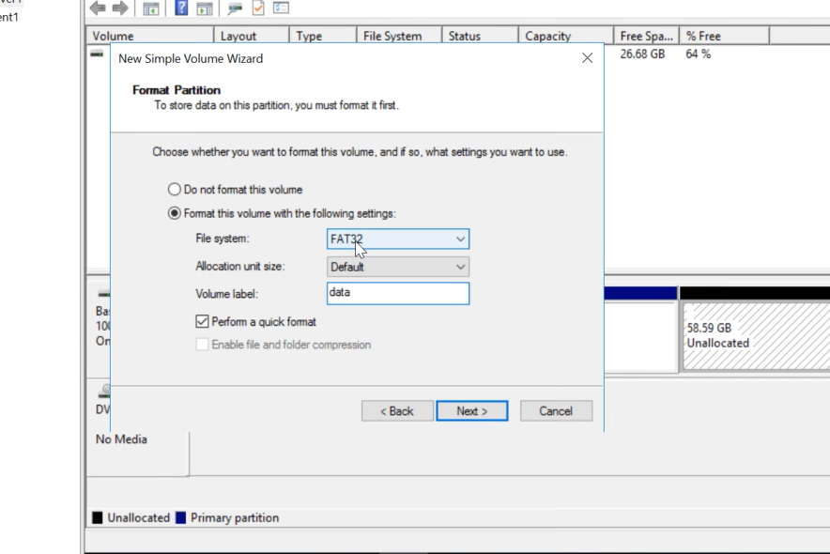
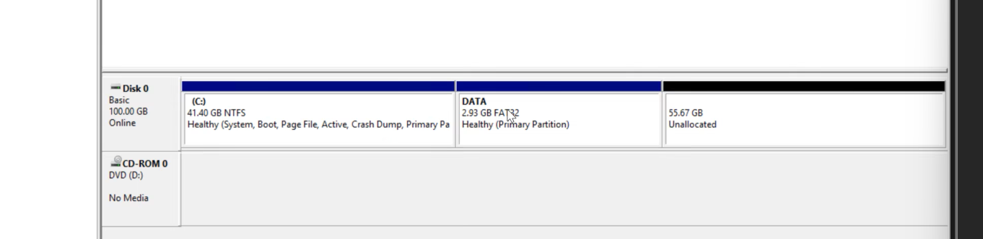
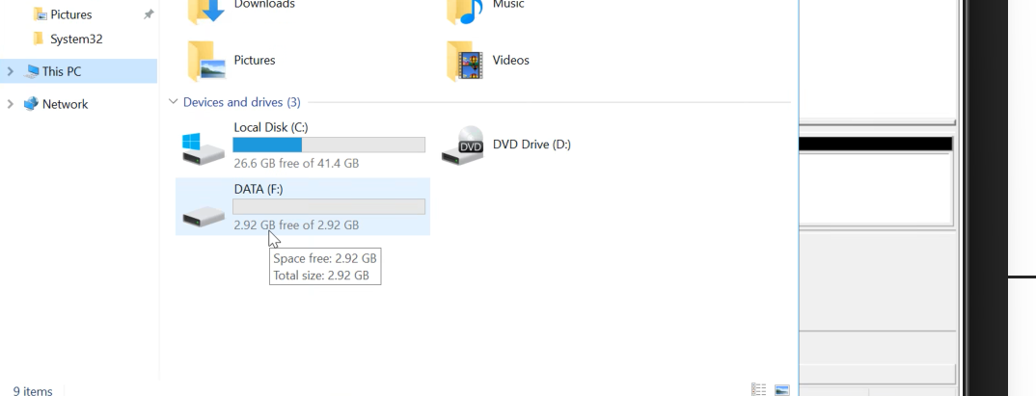
and similary for rest 2 …
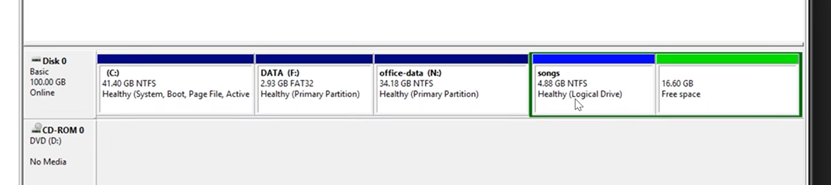
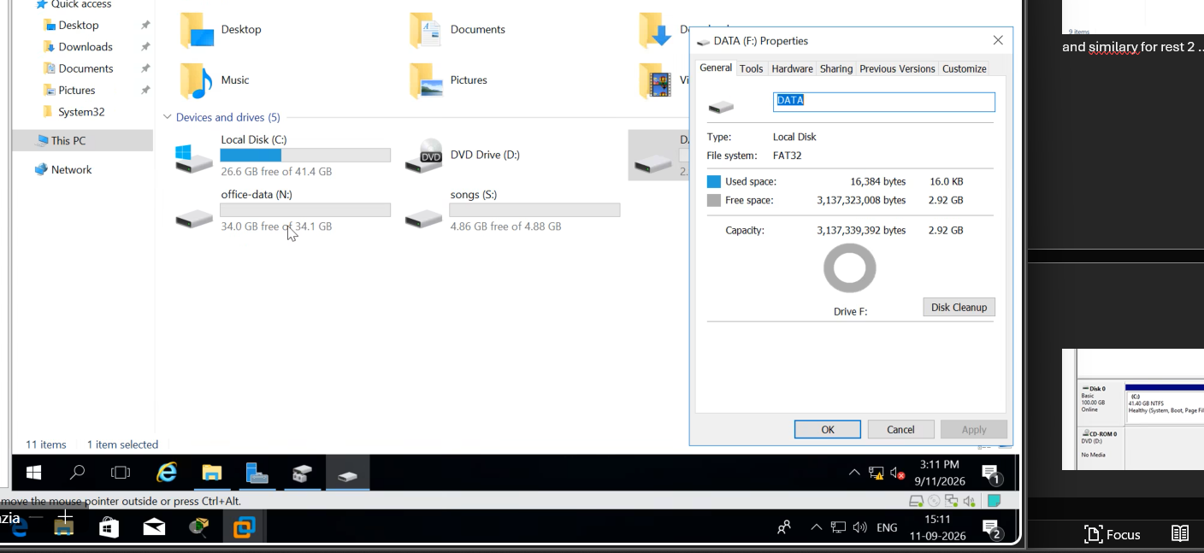
mkc imp hai bkl
2nd
aim to conversion of fat32 into ntfs without losing data
ans
open cmd
type the command:- convert m: fs fs:/ntfs
the drive symbol
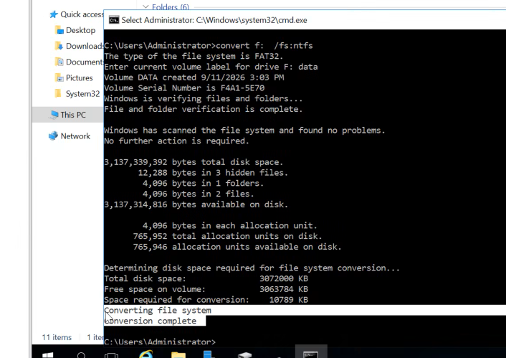
WE can only upgrade …we cant downgrade
fat to ntfs allowed
ntfs to fat not allowed
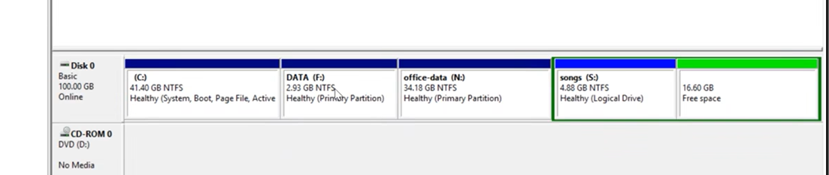
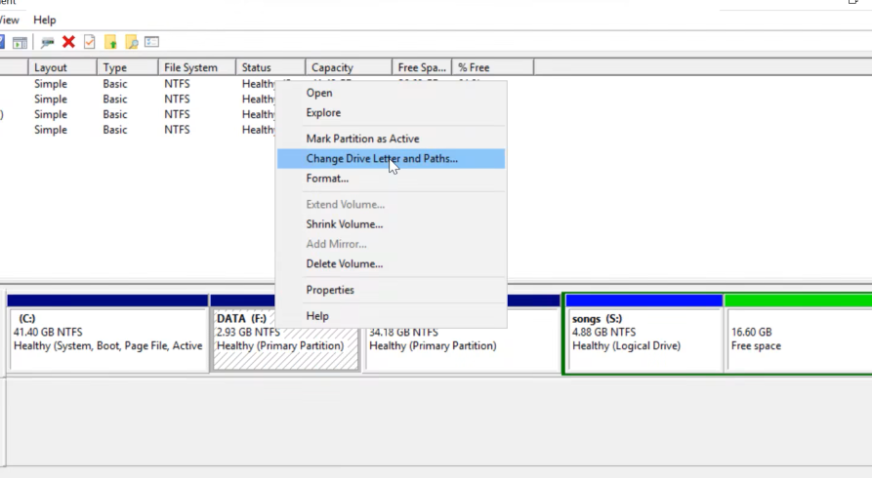 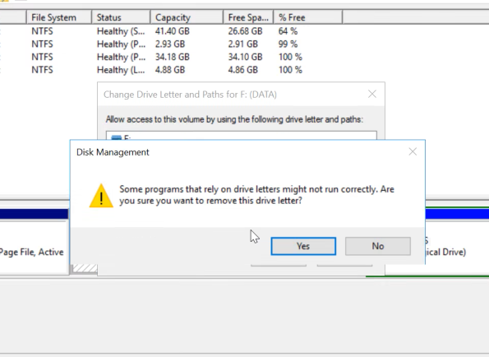
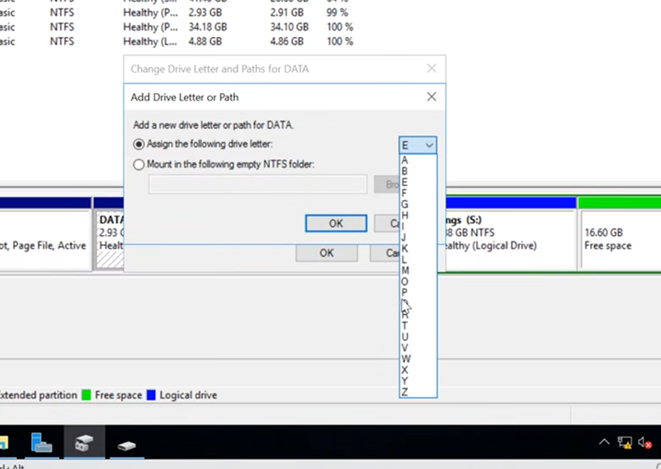
if alll letters over then norms …
we should
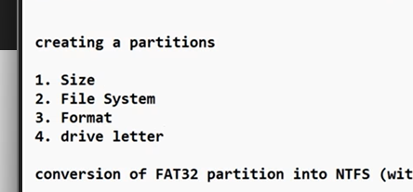
we do formatting for making partitions bkl
formatting is defining file system and cluster size
4 sectors make 1 cluster…bc 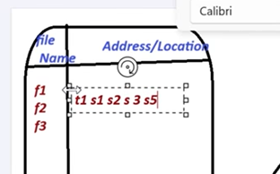
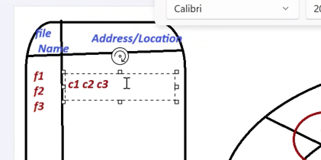
os decides the file and cluster size ..while formatting bc…
cluster are make to make the work easy and easy entry in table bc
If cluster size is kept big ..more space is wasted …
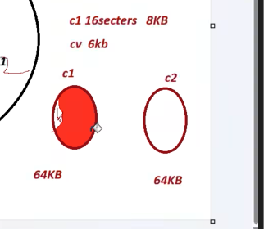
Actual 6 kb
size on disk 64kb
hence make small clusetr ideally 4 kb
Dynamic disk
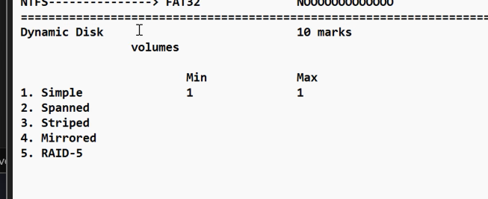
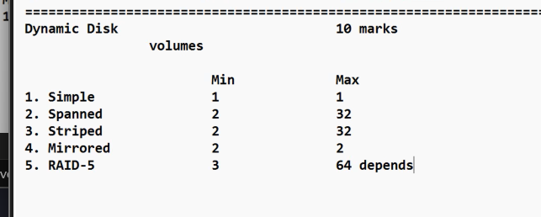
AIM::--
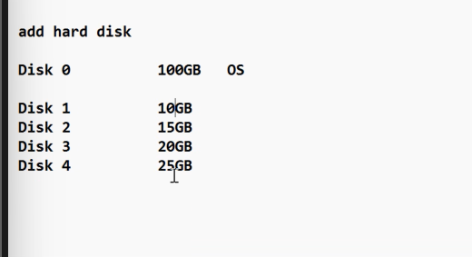
server1Settings
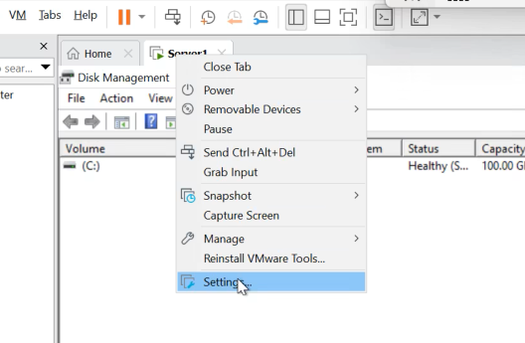
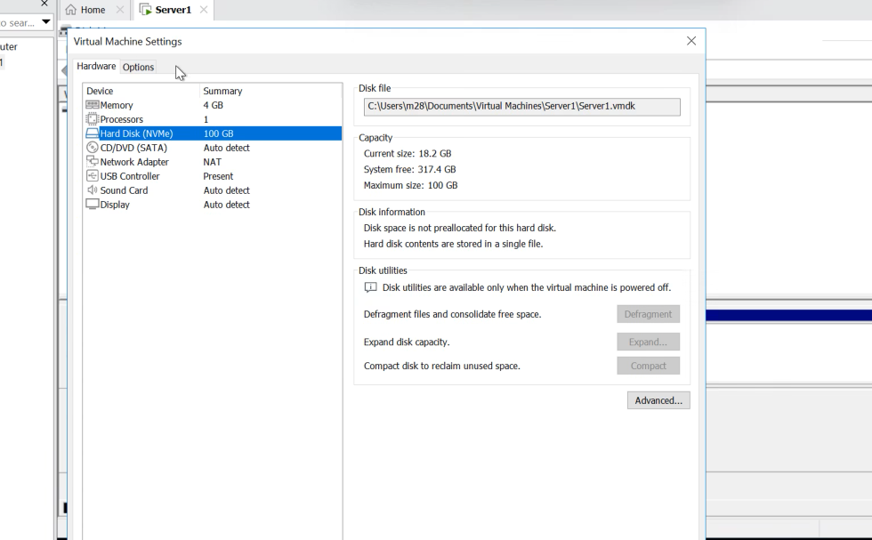
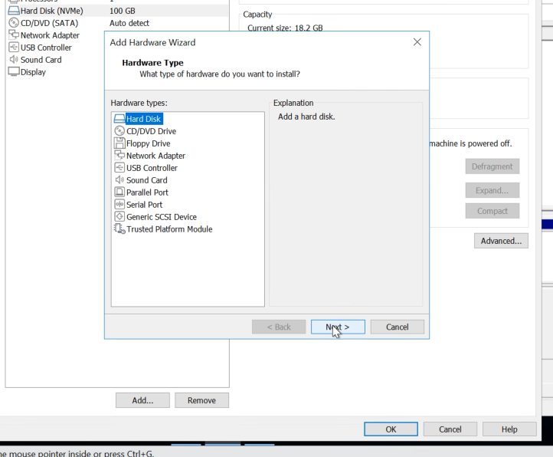
next next
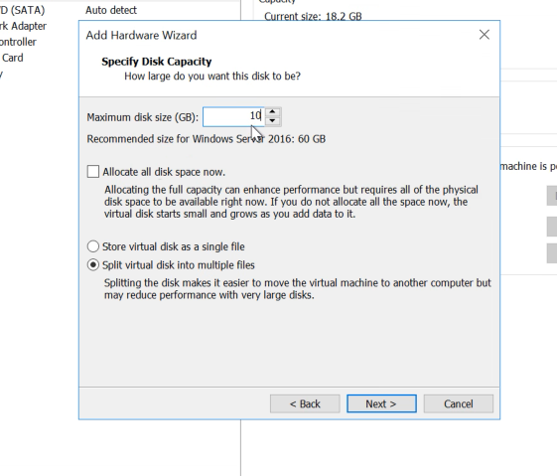
next finish

Similary the rest bc
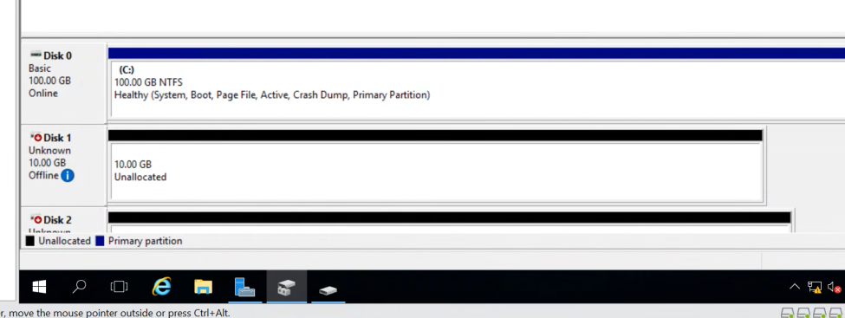
and click ohhk ignore it will restart once you….
right click and make them online and then initialize
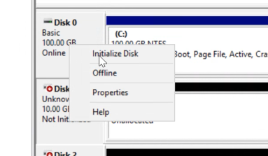
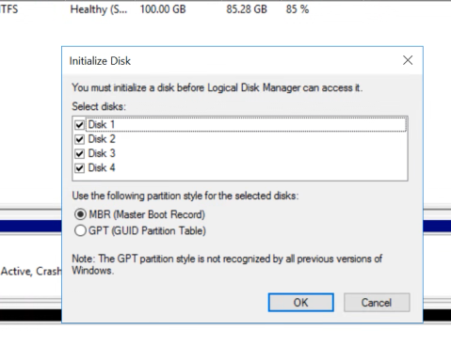
and now its online
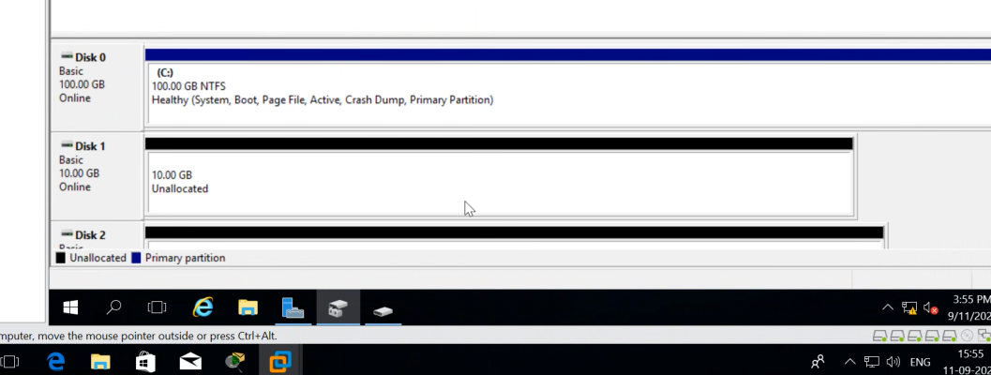
final screen shott
Bc
Now make partitions in this ..5gb ka
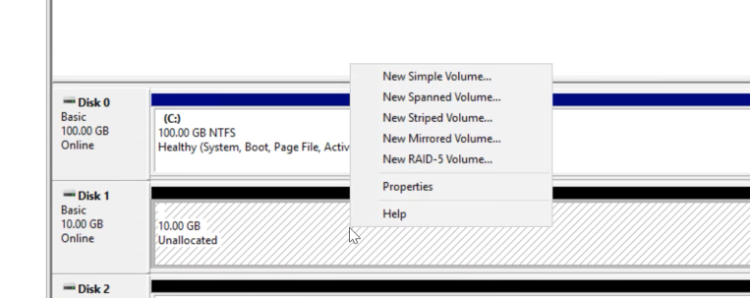
till now its simple this is how we get to convert it ..
